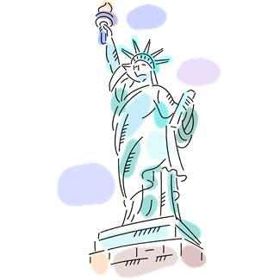
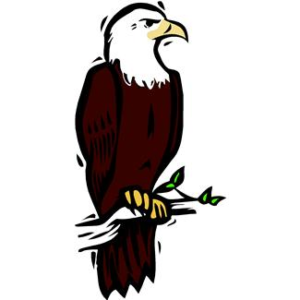
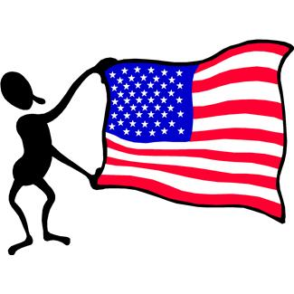

Patriot Symbols and Traditions Homework
Return by Friday, March 1st

Dear Families,
This week we are learning about patriotic symbols and traditions that represent the United States of America, and what it means to love and respect our country. Please complete this interview with your child. We will share our what we learn as a class throughout the week.
Thank you!

- What country is our family from? _________________
Label it on the world map.
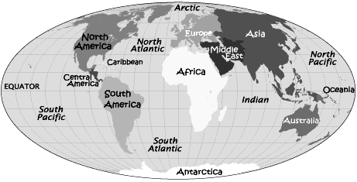

- What language(s) do we speak at home? ______________________________________________________

- Do we have any family traditions? Yes/No
If yes, what are they?
_______________________________________________________________________________________________________________________________________

- Are there any symbols that represent our home country? (Draw one of them together)
_______________________________________________________________________________________________________________________________________

