Meredith Forbes
May 5th 2013
What are they Thinking Assignement
First Grade
Patriotism and the Pledge of Allegiance

Questions:
- What does it mean to you to show respect for your country? (draw a picture of you showing respect and love for your country)
- Why do we say the Pledge of Allegiance?
- What do the words mean?
- What does Liberty and Justice for all mean?
- What is your country? Why?

Student #1: Franco
T: Why do we say the Pledge of Allegiance?
S: to….I don’t know
T: What do you think it means?
S: that we believe in god?
T: What does Liberty and Justice for all mean?
S: I don’t really know…
T: What is your country?
S: The United States and Argentina
T: Can you say more about that…
S: Well my mom and dad are from Argentina and we live here in the United States, that’s why

Draw a picture or write with words how you show love and respect for your country
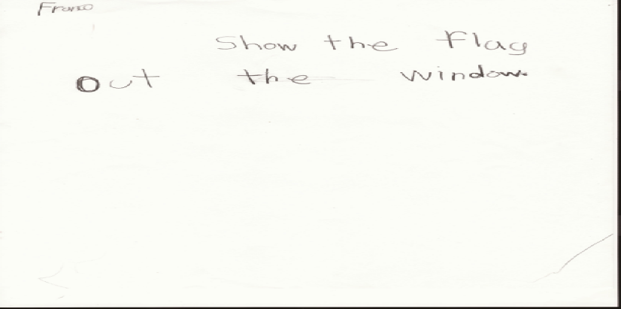

Student #2: Victoria
T: Why do we say the Pledge of Allegiance?
S: Because we have to say it for our state
T:What do you mean by that? what is our state?
S: America
T: what does it mean?
S: it means that we have to sing for our country
T: What does it mean? What do the words mean?
S: for the United States of America….uhhhhh, I don’t know
T: What does Liberty and Justice for all mean?
S: For….for….I don’t know

T: what is your country?
S: Bolivia, Argentia, and the United States of American
T: why all three?
S: because they are both where I live. First, my mom is from Bolivia, my dad is from Argentina, and I am from the United States of America.
T: so it’s like where oyur family lives? How do you show love and respect for your country
S: Dancing and signing
T: tell me more..
S: dancing like of my country and eating the food of my country
T: because it has food, and the food is my favorite food..and food is love, and I love my countries.

Draw a picture or write with words how you show love and respect for your country
Victoria: “because my country has food that is my favorite, and food is about love, and I love my country”
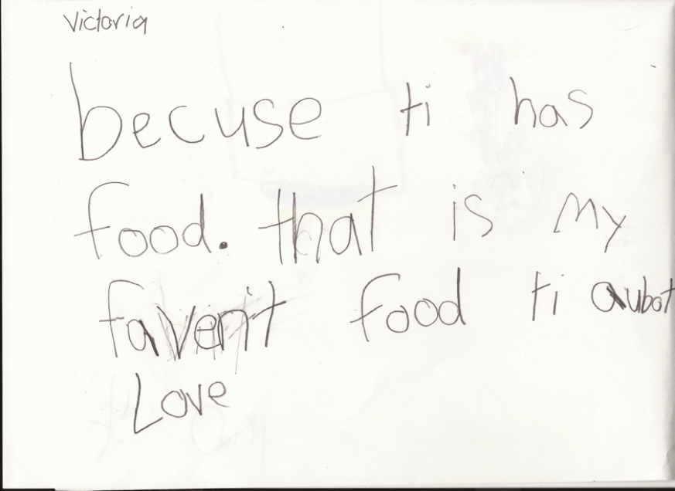

Student #3: Estefani
T: Why do we say the Pledge of Allegiance?
S: because like, because….like, when you say the Pledge of Alleienge…you…I don’t know
T: What does it means? What do the words mean to you?
S: It means..like, when you say the Pledge of Alleigance, it means like you look like….you…I don’t know
S is not able to say the Pledge independantly
T: What does Liberty and Justice for all mean?
S: It means like, when you say it…like you have to look at the flag, and you have to say the words, and repeat it when you look at the flag on the smart board
T: Why do we say it every morning?
S: because….becuase when you say it every morning, like…it means…I don’t know

Draw a picture or write with words how you show love and respect for your country
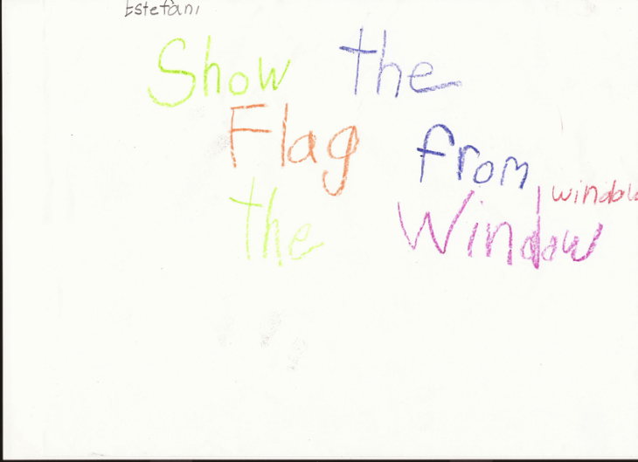

Student #4: Marian
S: to respect our country
T: What does that mean?
S: to show love to our country, to show that we love the United States of American because we live there…for real
T: what do you mean for real?
S: we say the Pledge of Allegiance in school so we can respect our country
T: What does the Pledge of Allegiance mean?
S: That you say to love your country
T: can you explain a little bit more..
S: because its’ where we live and we have to show love
S: says the Pledge of Allegaicne without words or prompting
T: What does Liberty and Justice for all mean?
S: to say that you love your country. If we see the SoL, we have to show respect and love to our country.
T: What does Liberty and Justice for all mean?
S: that means that you have to show respect if you see the Statue of Liberty, and the liberty island.

Draw a picture or write with words how you show love and respect for your country
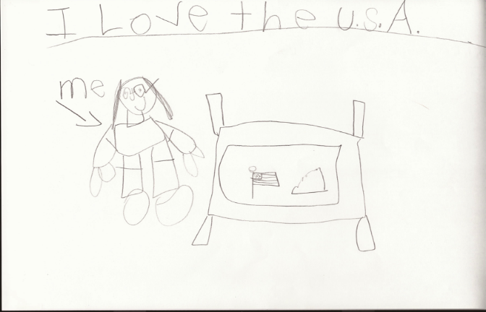

Student #5: Andy
S: If you don’t say it than you might get introuble in school, and if you arent doing it, then someone might tell on you and
T: What does it mean? What do the words mean?
S: its patriotic…I don’t know
S: recites with some prompting and support
T: What does Liberty and Justice for all mean?
S: I don’t know
T: What is your country?
S: Vietnam
T: Can you say more about that?
S: I speak Vietnam at home and we are from there
Draw a picture or write with words how you show love and respect for your country
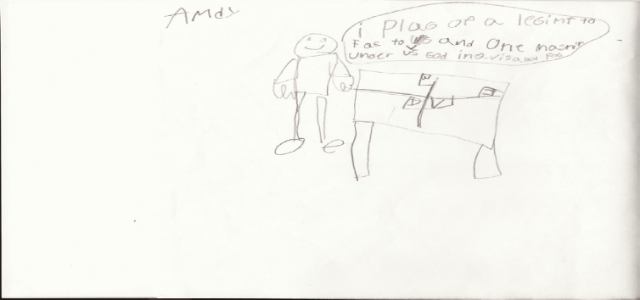

Student #6: Nancy
T: why would you say that Vietnam is your country?
S: because my mom was born there, and I was born there too. I can’t say English at my house, only Vietnam. We only speech vietnamese.
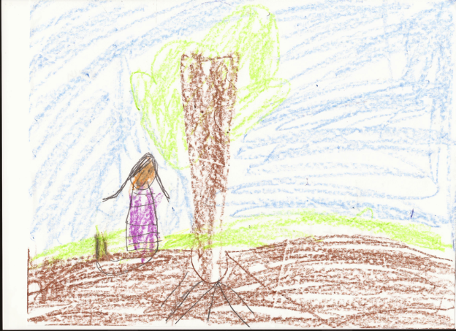
T: think about how you show love and respect fo your
S: never leave tras anywhere, and help your friends
T: why do we say the Pledge of Allegiance?
S: because that is patriotic
T: what does that mean by that?
S: means you are doing something that
T: why do you say it?
S: Westlawn means..the eagles of our country?
T: why do we say it every morning?
S: because…it represents the Eagle
T: what does?
S: When we say the Pledge of Allegaince
T: why do we say it?
S: because it represents the eagles and it’s nice to our country.
T: What does Liberty and Justice for all mean?
S: Liberty….that we have liberty inside. I forgot what it means.
Draw a picture or write with words how you show love and respect for your country
Nancy: “I show love for my country by not throwing trash on the ground and by being kind to the earth so our country can be pretty”
Reflection:

After interviewing the students in my class about the concepts of patriotism and reciting the Pledge of Aalegaince, I was very intreiged by student responses. First off, I was facilitating these interviews after I taught the unit on Patriotic Symbols and Traditions, so the interview also served as a post assessment of the unit and gave me insight into what concepts students remembered and understood. The first set of questions was about the Pledge of Allegiance, and it’s purpose and place in our schools. I was not surprised that many of my students were not able to give reasoning behind why we recite it in school every morning. The practice of reciting the Pledge at my school is not taking very seriosuly in my classroom and compliance with strict rules for how to say it are not enforced. For exmple, many students do not stand up right away or recite the words in unison with the class or the loud speaker. Implications for my future teaching on this subject will include a class discussion prior to the unit to talk about the words of the Pledge of Allegiance, line by line, and generate a shared understanding of what the words means. There are lines in the Pledge of Allegiance that I believe do have relavance to students today if we look at it through the lens of our own experiences and cultures. I am personally coming to terms with my own views on the Pledge of Allegiance and it’s place and purpose in our schools, and I want students to find meaning in it that reaches beyond just obligatory school practice.
It was also very interesting to see how students showed patriotism in their drawings. When teaching this unit, we talked about patriotic traditions and gave examples like flying the American Flag, and saying the Pledge of Allegience, because those are two essential understanding according to the Virginia standards. I learned so much more from students by asking them to draw or write how they showed love and respect for their country, and even with just six student responses, got a variety of new examples. For example, Nancy drew a picture and described picking up trash, not littering, and being kind to the Earth as a way she loves her country. Victoria talked about dancing, signing, and eating her favorite foods from Boliva as a way she shows love for her country. These were just two examples that I could highlight and reference in the teaching of my unit to elicit more examples from other students to generate a more authentic and culturally inclusive list of patriotic traditions than just what the standard includes. Including traditions like the ones Nancy and Vicotoria shared with me will also help students connect their personal lives and experiences to the content we are teaching, providing for a more engaging and culturally relevent unit.
The second concept that I asked students about had to do with the idea of identity and their country. I asked students to name their country, and was delighted to hear students refere to their country as both their country of ethnic origian, and the United States, where they live and where most of my students were born. These conversations have exciting implications on my teaching of this unit, beucase it allows me to take the concept of patriotism outside the scope of just the United States of America, and look at patriotism as a broader concept where we love and respect our country of origin, the coutry our parents came from, the country where we were born, and the country where we live.
For future teaching, I am going to begin my unit to taking an inventory of all the places where my students identify as home to them, and use those country as a lens in which to talk about patriotism. We can connect patriotic traditions in the United States, like saying the Pledge of Allegiance and flying the American Flag, to patriotic traditions of other countries that students share from home. These interviews affirmed my beleif that teaching patriotism does not mean teaching our kids just about the United States, but can provide a great opportuntiy to talk about being patriotic to more than one country, and what it means to be a citizen of more than one nation.

Performance Guidelines

When thinking about Category 3 for your self-evaluation, consider these following criteria:

Blazing New Ground (2)  How have you gone above and beyond expectations? | Staying on Track (1)  How have you met expectations? | Getting Off Track (0)  How have you fallen short of expectations?
- Selected a provocative and powerful term/concept that is connected to your unit’s topic  - Creatively documented more than five students’ thinking  - Wrote an articulate, thoughtful reflection related to what you learned about students’ thinking and the process of soliciting students’ ideas  - Unit clearly reflects your application of what you learned from your students | - Selected a term/concept connected to your unit’s topic  - Documented at least five students’ thinking  - Wrote a reflection related to what you learned about students’ thinking in relation to your unit  - Some evidence of student thinking shaping your lesson plans | - Selected a term/concept not related to your unit’s topic  - Documented less than five students’ thinking  - Wrote a shallow reflection or no reflection  - Little to no evidence of student thinking shaping your lesson plans

